THE BIBLE TREE
A Guided Walk
Draft v4, stops 0 to 9. October 27, 2026. Michlaude Discipleship Project. Read alongside the picture, “The Bible Tree.”
Scripture quotations are taken from the NET Bible® Second Edition (New English Translation), © 1996–2019 Biblical Studies Press, L.L.C. All rights reserved. Permission to quote granted by David Austin, Permission Director, Biblical Studies Press, July 1, 2026. NET Bible text reproduced by permission. No derivative works permitted.

Stop 0. Two Bibles, one verse
Open two Bibles to Isaiah 53:11.
In the NIV (New International Version), the verse says the servant “will see the light of life.” In the ESV (English Standard Version), it says only that he “shall see.” Then you find a small footnote.
Did someone change the Bible? No. Something more interesting happened. The old copies of this verse do not all match.
Three very old Hebrew scrolls say “light.” So does the old Greek Bible. The standard Hebrew text, copied later, does not. The NIV followed the older scrolls. The ESV kept the standard text and told you about the other wording in a footnote.
Both Bibles were honest about what the copies say. They made a different choice about which copy to trust.
To see why copies can differ, we have to ask where a Bible comes from. That is what the tree shows. We will start at the bottom, with the roots.

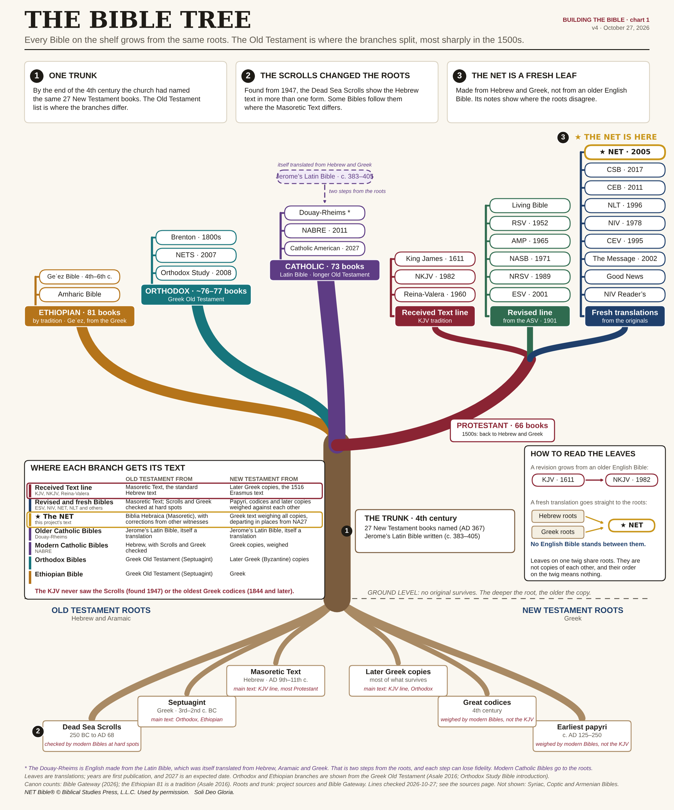
Figure 1. The Bible Tree, v4. Leaves are translations; years are first publication, and 2027 is an expected date. The Douay-Rheims (*) has an extra step through Jerome’s Latin Bible.

Stop 1. The roots: copies all the way down
Nobody alive has seen the original pages of the Bible. The ink dried thousands of years ago. What we have are copies, and copies of copies, all made by hand.
Look at the roots of the tree. On the left are the Old Testament roots. The Old Testament was written in Hebrew. On the right are the New Testament roots. The New Testament was written in Greek. Each root tip is a group of old copies. The deeper the root, the older the copy.
On the Old Testament side, the Dead Sea Scrolls go deepest. They are Hebrew scrolls from about 250 BC to AD 68. The Septuagint is the Old Testament translated into Greek about 2,100 to 2,300 years ago. The Masoretic Text is the standard Hebrew text. Jewish scribes copied it with great care. A scribe is a person whose job was copying books by hand. The oldest complete copy of this text is from about AD 1008.
On the New Testament side, the oldest pieces are the earliest papyri, from about AD 125 to 250. Papyrus is an ancient kind of paper made from a plant. Next come the great codices, which are big books from the 300s. Last are the later Greek copies. Most of what survives is in that group.
After thousands of copies, you would expect small differences, and that is what we find. Most are tiny, like spelling. A few matter. Scholars treat them like detectives. They ask which copy is oldest, and which change makes sense. A scribe might write a helpful note in the margin. The next scribe might copy that note into the text. So the longer wording is often the later one.

Stop 2. The ground breaks open: the Dead Sea Scrolls
Before 1947, the oldest big Hebrew copies of the Old Testament came from about nine hundred to a thousand years after Jesus. Then scrolls were found in caves near the Dead Sea, and more turned up over the next nine years.
Those scrolls pushed our oldest Hebrew copies back by a thousand years or more. The good news came first. The Great Isaiah Scroll, from about 125 BC, agrees closely with the standard Hebrew text. The scribes copied with great care.
Then came the surprise. The scrolls show that the Hebrew text was already being copied in more than one form. In a few places, they agree with the old Greek Bible against the standard Hebrew text.
Isaiah 53:11 is one place. Deuteronomy 32:8 is another. The standard Hebrew says the nations were divided by the number of the “sons of Israel.” The scrolls say “sons of God.” The Greek says “angels of God” in most copies. Both point to heavenly beings. Five modern Bibles put the older wording in their text: the ESV (“sons of God”), the NET (“heavenly assembly”), the NLT (“heavenly court”), the NRSV (“the gods”) and the NABRE. The KJV (King James Version) follows the standard text with no note. The NIV, the NKJV, the CSB and the 2020 NASB follow it too, and they tell you about the older wording in a footnote.
In 2025, a team of scientists dated the scrolls again. They used carbon dating, which is a way to measure how old something is, on 30 manuscripts. Then they trained a computer program that studies handwriting and used it to date 135 more. They found that the old handwriting dates were often too young. Many scrolls are older than people thought.
What the scrolls do not do is show that the Bible was lost or changed. A few places where copies differ is what you would expect after two thousand years of copying by hand. The surprise would be if there were none. And the scrolls give us something priceless: older witnesses to compare.
On the tree, this is box 2.

Stop 3. The trunk: one list of New Testament books
Now move up from the roots to the trunk. This is the fourth century, the 300s.
By then, most churches had used nearly the same New Testament books for generations, though a few books, such as Hebrews and Revelation, were still debated in some places. In the year 367, a bishop named Athanasius wrote a letter that named exactly 27 books. They are the same 27 in your Bible today. Later, church councils in North Africa, at Hippo in 393 and at Carthage in 397 and 419, named the same 27. Those were regional councils, and the Hippo list survives only because Carthage repeated it.
Nobody voted the Bible into existence at one meeting. By the end of the 300s, the church had named a list it was already using. The word for that official list of books is the canon.
The Old Testament list was not settled so neatly. A scholar named Jerome made a famous Latin Bible, working from about 383 to 405. He said the Old Testament should be the books in the Hebrew Bible. A bishop named Augustine listed a longer set of Old Testament books, and the church kept using them. That disagreement ran for more than a thousand years. In the 1500s, Protestants chose Jerome’s shorter list, and the Council of Trent confirmed the longer one. That is where the branches split.
So nearly every Christian Bible today has the same 27 New Testament books. The Old Testament is where they differ.
On the tree, this is box 1.

Stop 4. The four branches
Look at the branches. Each one has its own Old Testament and its own number of books.
The Ethiopian branch. The church in Ethiopia put the Bible into its own language, called Geʿez, from the 300s to the 500s. It worked from the Greek Old Testament. The church counts 81 books, but that number is a tradition. No church council is known to have fixed it, and the lists of which books make up the 81 differ. The Book of Enoch, which survives in full only in Geʿez, is part of its Bible. The first bishop of Ethiopia, Frumentius, was consecrated by Athanasius, the same man who wrote the letter naming the 27 books.
The Orthodox branch. The Orthodox Church uses the Greek Old Testament, the Septuagint. Its Bibles have about 76 or 77 books, depending on the church. Scholars call its canon open, because it has no single fixed list.
The Catholic branch. The Catholic Church follows Jerome’s Latin Bible and the longer Old Testament list. That makes 73 books. A church council at Trent, in 1546, stated the list. The English Catholic Bible used today is the NABRE, which stands for New American Bible, Revised Edition. A new one, the Catholic American Bible, is expected in 2027. Its publisher gives Ash Wednesday, February 10, as the date.
The Protestant branch. In the 1500s, Protestants went back to the Hebrew Old Testament and the Greek New Testament. They kept the Hebrew list for the Old Testament, which has 39 books, and added the 27 of the New. That makes 66. Luther put the longer-list books in a separate section, and the KJV of 1611 printed them between the Old and New Testaments.
Catholics and Orthodox say the longer list is the one the early church used. Protestants say the Hebrew list came first. Serious Christians still disagree here, and the tree shows all four branches.
The box at the left of the trunk. Find the box called “Where each branch gets its text.” It answers one question for each family of Bibles: what did the translators work from? The first column is the Old Testament. The second is the New. Here is the box in words.
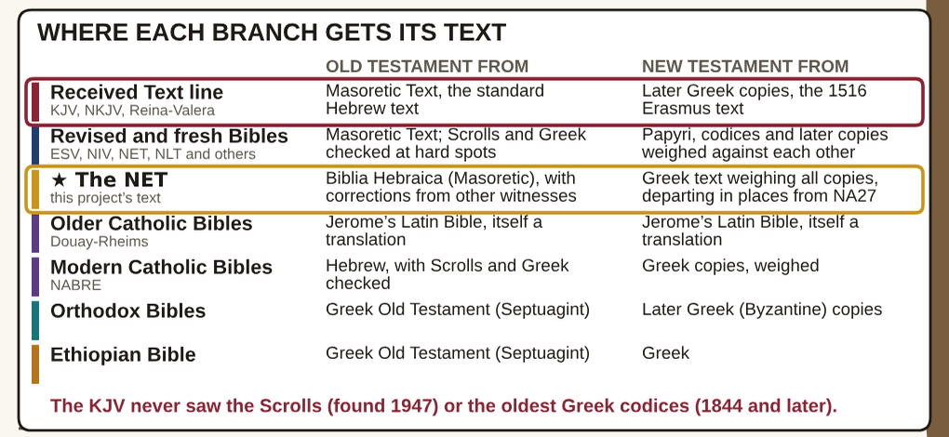
Figure 2. Where each branch gets its text (detail from the tree). Every line was checked on October 27, 2026; the apparatus at the end says what each rests on.
The Received Text line (the KJV, the NKJV and the Reina-Valera). The Old Testament follows the standard Hebrew text, the Masoretic Text. The KJV used the form that Daniel Bomberg printed in 1524 and 1525. The New Testament follows the later Greek copies, the line that starts with Erasmus’s Greek of 1516. The NKJV names the same base for its New Testament. The first Reina-Valera, in 1569, used the same two kinds of text. It was made 42 years before the KJV and does not come from it. The Reina-Valera of 1960 revised that old Spanish Bible. The sources we could read describe its New Testament as the same Received Text, but we did not find the revisers’ own statement of their base.
The revised and fresh Bibles (the ESV, NIV, NET, NLT and others). The Old Testament is still the Masoretic Text, but the translators check the Scrolls, the Septuagint and other old witnesses at hard spots. The ESV preface says it translates a hard Masoretic reading as it stands where it can, and turns to the other witnesses only in difficult cases. The NLT and the CEB name the same kind of base. The New Testament comes from Greek editions that weigh all the old copies, the early papyri and the great codices as well as the later ones. The NASB is a revision of the American Standard Version. Its preface says its Old Testament comes from Kittel’s Hebrew Bible with help from the Scrolls, and that its New Testament mostly follows Nestle’s Greek text.
The NET. Its Old Testament follows the standard Hebrew text, the Biblia Hebraica Stuttgartensia, and the translators sometimes corrected it from other manuscripts, from old translations and from the Scrolls. Its New Testament follows a Greek text that weighs all the copies. The preface says that text departs in places from the Nestle-Aland 27th edition and the United Bible Societies’ fourth edition. Stop 8 comes back to it.
Older Catholic Bibles (the Douay-Rheims). Both columns say “Jerome’s Latin Bible, itself a translation.” These Bibles were made from the Latin, not straight from Hebrew and Greek. Jerome worked on the Latin Bible from about 383 to 405. He translated most of the Old Testament from Hebrew, and Tobit and Judith from Aramaic. The Psalter in Vulgate Bibles is the Gallican Psalter, which he made from the Greek. Wisdom, Sirach, Baruch and the Maccabees stayed in the older Latin text, which was made from Greek. The Latin New Testament is the older Latin text corrected against Greek copies. Jerome corrected the four Gospels, and we do not know who corrected the rest. So the Douay-Rheims is a translation of a translation, as Stop 7 says.
Modern Catholic Bibles (the NABRE). These go back to the roots. The NABRE’s Old Testament follows the Masoretic Text, with some corrections from the Septuagint and the Scrolls. The books in the longer list follow the Greek Old Testament, and the Scrolls where they survive. Its New Testament follows the United Bible Societies Greek text, third edition, with the Nestle-Aland 26th edition consulted.
Orthodox Bibles. The Old Testament is the Septuagint. The New Testament is the Byzantine text, the Greek of the later copies. In 1904 the Ecumenical Patriarchate in Constantinople published a standard edition of it, called the Patriarchal Text. One scholar counts 116 manuscripts behind it, all used in Orthodox worship, and they come mostly from the 900s to the 1300s. No single Greek New Testament is accepted by every Orthodox church.
The Ethiopian Bible. The New Testament was translated from Greek. So was the Old Testament, from the Greek Old Testament, between the 300s and the 500s. It was revised later, most likely in the 1300s, against Arabic Bibles.
What the tree leaves out. The tree does not show the Syriac, Coptic or Armenian Bibles, or many other English Bibles. It maps the Bibles on this shelf, not every Bible.
How the box was checked. Every line in the box was checked against the sources listed in the apparatus at the end. Where we could read only a summary and not the publisher’s own words, that section says so.

Stop 5. The twigs and leaves: where your Bible sits
Follow the Protestant branch to the top. It splits into three twigs. Each leaf is one translation.
First, learn how to read a leaf. A leaf can be a revision. A revision grows from an older English Bible. The NKJV is a revision of the KJV. A leaf can also be a fresh translation. A fresh translation is made straight from Hebrew and Greek, with no English Bible in between. Leaves on the same twig share roots. They are not copies of each other.
The Received Text line (left twig). In 1516, a scholar named Erasmus published the first Greek New Testament. He worked fast, from a handful of late Greek copies. The KJV was finished in 1611 by 47 scholars. For the New Testament, it used Erasmus’s Greek. For the Old Testament, it used the standard Hebrew text. The scholars also read earlier English Bibles, such as Tyndale’s.
That is the KJV’s whole root: two tips on the tree, the standard Hebrew text and the later Greek copies. It never saw the Dead Sea Scrolls, found in 1947. It also lacked the great Greek codices as scholars use them today. Codex Sinaiticus was found in 1844 and 1859. Codex Vaticanus sat in the Vatican library, but it was closed to most scholars until the 1800s. Codex Alexandrinus reached England in 1627, after the KJV was done. That is no fault of the translators. Those books were out of their reach. His Greek, called the Received Text, stayed the standard Greek New Testament for more than three hundred years. The NKJV and the Spanish Reina-Valera follow the same roots.
The Revised line (middle twig). These Bibles grow from the American Standard Version of 1901, which came from the Revised Version of 1881. The RSV of 1952 revised the ASV. The NRSV of 1989 and the ESV of 2001 revised the RSV. The NASB of 1971 revised the ASV directly. The Amplified Bible and the Living Bible are also built on the ASV. Their translators used the older Greek copies found after the KJV, and the later ones check the Scrolls at hard spots.
Fresh translations (right twig). The NIV (New International Version), the NET (New English Translation), the NLT, the CEB and others were made new from Hebrew and Greek. Like the revised line, they weigh all the Greek copies and check the Scrolls. Two leaves on this twig are later editions, not new translations: the CSB (Christian Standard Bible) revises the HCSB, which was new in 2004, and the NIV Reader’s Edition rewrites the NIV at an easier reading level. The NET sits at the top of this twig. We will come back to it.
The other leaves on the tree. The tree has more leaves than we have named. Here is what each one is.
Leaf | What it is
Living Bible, 1971 | A paraphrase by Kenneth Taylor. He retold the American Standard Version in plain, modern English.
AMP, 1965 | The Amplified Bible. It adds extra words in brackets to bring out shades of meaning. Its New Testament is based on the American Standard Version, and its Old Testament leans on the RSV.
NLT, 1996 | The New Living Translation. It began as a revision of the Living Bible, then became a new translation from the Hebrew and Greek.
CEV, 1995 | The Contemporary English Version, from the American Bible Society. A new translation, written for readers who find Bible language hard.
Good News, 1976 | Also called Today’s English Version, from the American Bible Society. It is translated from the Hebrew and Greek, thought for thought.
The Message, 2002 | Eugene Peterson’s version, often called a paraphrase. He worked from the Hebrew and Greek and retold it in everyday speech.
NIV Reader’s, 1996 | The NIV rewritten at an easier reading level.
CEB, 2011 | The Common English Bible. A new translation by about 120 scholars from 24 denominations.
Brenton, 1800s | An English translation of the Septuagint by Sir Lancelot Brenton, first published in 1844 and made from the Vatican text of the Greek. A Greek and English edition followed in 1851. It sits on the Orthodox branch.
NETS, 2007 | The New English Translation of the Septuagint. It starts from the NRSV’s wording and changes it wherever the Greek differs. It is a scholars’ translation, not a church Bible.
Orthodox Study Bible, 2008 | Its Old Testament is an English Septuagint from St. Athanasius Academy, built on the NKJV’s wording. Its New Testament is the NKJV.
Geʿez Bible, 4th to 6th century | The ancient Ethiopian Bible, in Geʿez, the old language of that church.
Amharic Bible | A Bible in Amharic, one of the main languages of Ethiopia today. It has several editions, and the tree gives no single year.

Stop 6. Three verses where Bibles differ
Now you can read a footnote like a detective. Here are three cases.
Case 1: Mark 16:9 to 20. These are the last twelve verses of Mark. The two oldest big Greek books, from the 300s, stop at verse 8. Almost all of the later Greek copies have the twelve verses. Today’s major English Bibles keep them, but every one except the KJV sets them apart with brackets, a line or a footnote. The KJV prints them with no mark at all. What does not change is the story of the resurrection, which all four Gospels tell. The footnote is not hiding anything. It is telling you what the oldest copies show.
Case 2: 1 John 5:7 and 8. The KJV has a longer wording here that names the Father, the Word and the Holy Spirit “in heaven.” Newer Bibles leave it out of the text. It shows up in Latin copies and a few late Greek ones, and Erasmus left it out of his first two editions. It was added centuries after John wrote. What does not change is the teaching of the Trinity, which the Bible gives in many other places. Matthew 28:19 is one, where Jesus names the Father, the Son and the Holy Spirit. The NET, NIV, NASB, CSB, NLT and NRSV leave it out of the text and put it in a footnote. The ESV and the NABRE leave it out and say nothing about it. The NKJV keeps it in the text and adds a footnote saying other Greek texts omit it.
Case 3: Psalm 22:16. The KJV says, “they pierced my hands and my feet.” The NIV (“pierce”), the ESV and the CSB (“pierced”) read the same way. The standard Hebrew text says “like a lion” my hands and feet. So does an old Jewish Bible, the Jewish Publication Society version of 1917. The old Greek Bible and the Latin Bible say “dug,” which is often translated “pierced.” A Hebrew scroll from Nahal Hever, from about AD 50 to 68, may say “pierced,” but scholars still argue about how to read it. What does not change is the rest of the psalm. The Gospels quote its other lines, such as “My God, my God, why have you forsaken me?”
Here is the rule. A footnote like these is the translators showing you their evidence. A Bible that shows you where the copies disagree is not weaker. It is asking you to look for yourself.

The tracer: one variant at a time
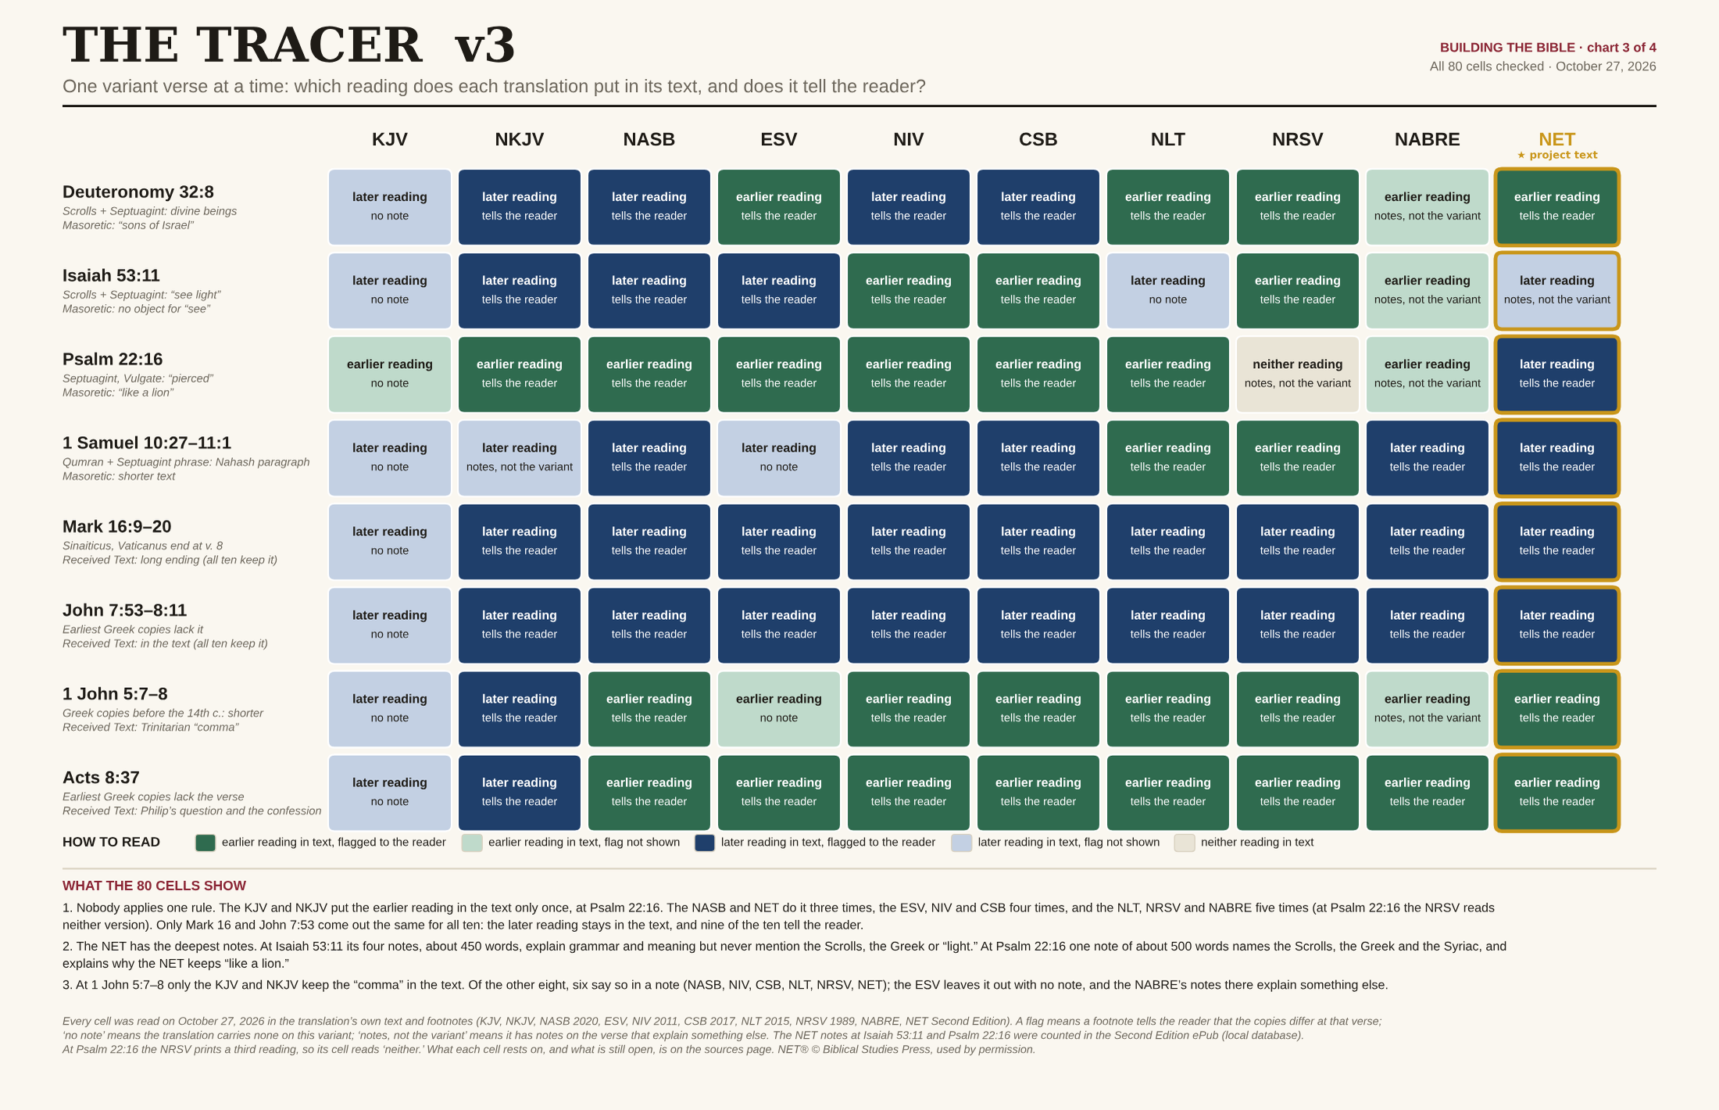
Figure 4. Eight verses across ten Bibles; all 80 cells were checked on October 27, 2026. Green and blue cells tell the reader about the variant; pale cells follow the reading but show no flag; the cream cell is the NRSV at Psalm 22:16, which prints neither reading. The NET notes at Isaiah 53:11 and Psalm 22:16 were counted in the Second Edition ePub (local database).

Stop 7. Four Bibles on one shelf
Put four Bibles side by side: a Catholic Bible, the KJV, the NIV and the NET. For the Catholic Bible we used the NABRE, the New American Bible Revised Edition, whose text the U.S. Catholic bishops’ conference posts online. Where the old Catholic English Bible, the Douay-Rheims, says something different, we say so.
Why would they differ at all? There are three reasons, and each one belongs to a part of the tree. Sometimes the copies themselves differ. Sometimes the translators chose different English words for the same Greek or Hebrew. And sometimes an old Latin Bible stood in the middle. The Douay-Rheims was made from the Latin Bible, not straight from Hebrew and Greek.
One warning about the Douay-Rheims: it is a translation of a translation. Jerome turned the Hebrew and Greek into Latin around the year 400. Then the English scholars at Rheims and Douay turned that Latin into English. Their title pages say it was translated “out of the authentical Latin” and checked against the Greek, and for the Old Testament against the Hebrew. Every step loses some fidelity. Most people read Challoner’s revision of 1749 to 1752, which borrowed much of its wording from the KJV and was checked against the Latin, so the tables below are not pure 1582 English. So when the Douay-Rheims differs from the others, it tells you what the Latin said. It does not always tell you what the Hebrew or Greek said. The NABRE is not made this way. Look for the label “(from Latin)” in the tables below.
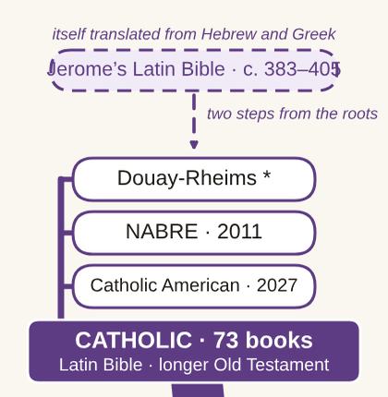
Figure 3. The Catholic branch. The Douay-Rheims reaches the English by way of Jerome’s Latin Bible; the NABRE goes straight to the roots.
Who crushes the serpent’s head? (Genesis 3:15)
Bible | What it says
KJV | “it shall bruise thy head”
NIV | “he will crush your head”
NET | “her offspring will attack your head”
NABRE | “they will strike at your head”
Douay-Rheims (from Latin) | “she shall crush thy head”

The Hebrew word here is “he.” The old Latin Bible had “she,” and the Douay-Rheims followed the Latin. Many Catholics link the “woman” to Mary. The Latin Bible the Vatican approved in 1979, the Nova Vulgata, reads “ipsum,” which is neuter and agrees with the Latin word for “offspring.” The NABRE uses “they.”
Virgin or young woman? (Isaiah 7:14)
Bible | What it says
KJV | “a virgin shall conceive”
NIV | “The virgin will conceive” (footnote: “Or young woman”)
NET | “this young woman is about to conceive”
NABRE | “the young woman, pregnant and about to bear a son”

The Hebrew word means a young woman. The Greek Old Testament translated it “virgin,” and Matthew quotes it that way in his first chapter. So this difference is a choice between two roots. The NET adds a note saying the young woman was probably someone present at the scene.
Repent or do penance? (Matthew 3:2)
Bible | What it says
KJV | “Repent ye”
NIV | “Repent”
NET | “Repent”
NABRE | “Repent”
Douay-Rheims (from Latin) | “Do penance”

Here the Catholic and the Protestant Bibles do not split. The old Douay-Rheims stands alone, because the Latin Bible said “do penance.” The Greek word means a change of mind. The modern Catholic Bible says “Repent,” like the rest.
The gates of hell? (Matthew 16:18)
Bible | What it says
KJV | “the gates of hell”
NIV | “the gates of Hades”
NET | “the gates of Hades”
NABRE | “the gates of the netherworld”
Douay-Rheims (from Latin) | “the gates of hell”

The Greek word is Hades, the place of the dead. The KJV and the Douay-Rheims both said “hell.” The newer Bibles keep “Hades” or say “netherworld.” Notice what does not change. All four Bibles read “on this rock I will build my church.” The fight over who the rock is comes from how people read the verse, not from how the Bibles translate it.
Prayer and fasting? (Mark 9:29)
A father brings his son to Jesus. The disciples could not cast out the demon. Jesus tells them how it is done.
Bible | What it says
KJV | “by nothing, but by prayer and fasting”
NIV | “only by prayer”
NET | “only by prayer”
NABRE | “only come out through prayer”
Douay-Rheims (from Latin) | “by nothing, but by prayer and fasting”

Here the KJV and the old Catholic Bible agree, and the modern Catholic Bible sides with the NIV and the NET. (In the Douay-Rheims this verse is numbered Mark 9:28.) The reason is the copies. Codex Vaticanus and the first writer of Codex Sinaiticus, two of the oldest big Greek Bibles, did not have “and fasting.” A later hand added it in Sinaiticus. Other Greek copies have it, among them Codex Alexandrinus and Codex Bezae, and so does Jerome’s Latin Bible. The KJV follows the later Greek. The Douay-Rheims follows the Latin. The NIV, the NET and the NABRE follow the older Greek. The Latin is still useful as a witness, because it shows what kind of copies Jerome had. But it cannot show us the Greek word for word.
The same saying shows up in Matthew 17:21. The KJV has it. The NIV leaves out the whole verse, and many scholars think a copyist added it to Matthew from Mark. None of this takes fasting out of the Bible. Jesus talks about fasting in Matthew 6:16 to 18, in every one of these Bibles. What changes is whether Jesus said it here, at this healing.
Where the copies differ, not just the words. These are the verses from Stop 6 and the tracer. At 1 John 5:7 and 8 and at Acts 8:37, the KJV has words that the NIV and the NET leave out. At Deuteronomy 32:8, the KJV and the NIV follow the standard Hebrew, and the NET follows the older reading, “heavenly assembly.” At Isaiah 53:11, the NIV follows the Scrolls and the Greek, and the KJV and the NET follow the standard Hebrew. The NABRE follows the older reading at Deuteronomy 32:8 and at Isaiah 53:11, and its notes at Isaiah 53:11 do not tell you about it.
One difference is not about words. The Catholic Bible has 73 books, and the KJV, the NIV and the NET have 66. The extra books are Tobit, Judith, Wisdom, Sirach, Baruch, and First and Second Maccabees, plus additions to Esther and Daniel.
So what does the shelf show? Most of the differences people argue about are not Catholic against Protestant. Many come from old Latin against modern translation. Others come from a choice between two roots. A few come from the copies themselves. Knowing which kind of difference you are looking at is half the answer.

Stop 8. Where the NET sits
Now go back to the top of the right-hand twig and find the gold leaf. This is the NET, the New English Translation.
The NET is a fresh translation. More than twenty-five scholars made it from Hebrew, Aramaic and Greek. No older English Bible stands between it and the roots. For the Old Testament, it uses the standard Hebrew text and keeps the Greek Old Testament in view. For the New Testament, it uses a modern Greek text that weighs the old copies. That puts it in the same family as the NIV, the ESV and the CSB. It is not a different Bible underneath.
What sets the NET apart is its notes. A translator’s note is a short note at the bottom of the page where the translators explain a choice. The NET has close to 60,000 of them. Think of a student who shows their work in math class. You can follow the steps, and you can check them.
We tested that. We compared the NET with other Bibles at eight verses where the copies disagree. Here is what we found.
The NET does show its work. Its notes are far longer than most footnotes. At Isaiah 53:11 the NET has four notes, about 450 words in all. The ESV has one footnote there of nine words. At Psalm 22:16 a single NET note runs about 500 words. It names the Dead Sea Scrolls, the Greek and the Syriac, and it explains why the NET keeps “like a lion.”
At several verses, the NET also tells you where the copies disagree. Psalm 22:16 is one. Deuteronomy 32:8 is another.
But at Isaiah 53:11, something is missing. The NET follows the standard Hebrew text there. Its four notes explain grammar and meaning. They do not mention the Dead Sea Scrolls or the Greek Old Testament, which both read “light.” The NIV and ESV footnotes do mention them. So the NET shows its work, but not always all of it.
One more thing we learned. An older version of the NET’s note at Psalm 22:16 was shorter, about 260 words, and left out the Scrolls. The current note, about 500 words, adds them. The notes are still being improved.
So here is a fair summary. The NET is a fresh translation with unusually deep notes. It is not a better text than its cousins, and it does not tell you everything. That is a good reason to read its notes next to another Bible’s footnotes.
On the tree, this is box 3.

Stop 9. Back to the measure
Here is the whole tree in one breath. The roots are old hand-made copies, Hebrew on one side and Greek on the other. The trunk is the fourth century, when the church named its 27 New Testament books. Four branches grew from it: Ethiopian, Orthodox, Catholic and Protestant. The Protestant branch splits into three twigs, and every leaf is a translation.
When you pick up any Bible, ask three questions.
First, which roots does it draw from? Is its Old Testament the standard Hebrew text, the Greek Old Testament, or both? Does its New Testament use the later Greek copies, or does it weigh all the copies?
Second, is it a revision or a fresh translation? A revision grows from an older English Bible. A fresh translation goes straight to the roots.
Third, does it tell you where the copies disagree? A Bible that shows you is not weaker. It is giving you the chance to look for yourself.
Now the hard question. Is this still God’s Word? Christians believe the original writings were God’s Word, without error. Nobody has those pages. So the work of comparing copies is how we get as close to them as we can. That work has gone well. The copies agree almost everywhere. The places where they differ are known, and good Bibles mark them. Nothing here means the Bible was lost. It means we have more witnesses than any other ancient book, and we can check them.
One last thing. The Bible is not the point. It is the tool. Jesus said what the point is, in the night before He died.
“Now this is eternal life—that they know you, the only true God, and Jesus Christ, whom you sent.”
— John 17:3 (NET)
The text is the instrument. The Person is the life.
Soli Deo Gloria.

Scholarly apparatus: sources and flags
How this was checked (2026-10-27). Mike’s order was that every claim in the walk, the tree and the tracer be checked against real sources before it stays. Each claim was read against the page named below. Publishers’ and translators’ own prefaces, the Bible texts and footnotes themselves, and scholarly articles came first; Wikipedia and blog pages were used only to find leads, and where a claim rests on one of them it is marked as secondary. Where a claim could not be confirmed it was either corrected to what could be, or kept and listed under “Not confirmed” at the end of this page. The raw research is in the project’s source folder (btb/verification_2026-10-27); only the 40 cells in the tracer’s lower four rows have a full line-by-line table there, and the other findings are recorded here in summary.
What was corrected. The Hebrew copies’ date range on the tree was AD 8th to 10th century; it is now AD 9th to 11th, with the oldest complete copy at about AD 1008. The earliest papyri were “about AD 125 to 200”; they are now AD 125 to 250. Jerome’s Latin Bible was dated 390 to 405 and is now about 383 to 405. The Amharic Bible’s year (1986) was removed because it was not confirmed. The Ethiopian Old Testament is no longer described as “later nudged toward Hebrew” on the tree, and Stop 4 now says only that it was revised later, most likely in the 1300s and against Arabic Bibles. The eleven daggers on the tree, which marked lines recalled from general knowledge, are gone, because each of those lines was checked. The Douay-Rheims label carries an asterisk and a footnote instead. “King James line” became “Received Text line”, because the Reina-Valera is in it and is not a KJV revision. The Revised line is labelled “from the ASV, 1901”. The tree’s last line now says the KJV never saw the oldest Greek codices (1844 and later), where it said “copies”. At Stop 8 the translators are “more than twenty-five”, and the claim that the Second Edition of 2019 added the Scrolls to the Psalm 22:16 note was removed (see Stop 8 below). On the tracer, 1 John 5:7 to 8 now reads “before the 14th c.” where it said “16th c.”; the NRSV’s cell there changed from “no note” to flagged; all 80 cells are now checked, and 36 of them changed from the v2 chart.
Stops 0 to 2: the Scroll dates and the Great Isaiah Scroll come from the project corpus (From Silence to Certainty); the 2025 re-dating (30 scrolls carbon-dated and 135 more dated by a program) from the University of Groningen and PLOS One; the Isaiah 53:11 witnesses from textandcanon.org and the UBS Handbook on Isaiah; the Deuteronomy 32:8 readings by translation from each translation’s own text and footnote. Stop 3: Athanasius AD 367, the North African councils at Hippo 393 and Carthage 397 and 419 (regional councils, with a few books still debated), Jerome’s Latin Bible about 383 to 405, and the Jerome and Augustine disagreement (project volume What Isn’t in Your Bible; Bible Gateway, “Why Are Protestant, Catholic, and Orthodox Bibles Different?”). Stop 4: Ethiopian canon and Geʿez Bible (Asale, 2016, The Bible Translator); Orthodox counts and the absence of an official list (Bible Gateway; Orthodox Study Bible introduction); Trent 1546 and Luther’s seven books (project volume); Catholic American Bible date (ECPA reports; Ascension Press; USCCB announcement). Stop 5: Erasmus’s Greek published in 1516 and the 47 KJV scholars (The Words That Were Added, Bible Gateway); the lineage of the Revised line from the 1881 Revised Version and the 1901 American Standard Version. Stop 6, case 1: the tracer, the Liberty University paper, textandcanon.org (about 1,650 of the Greek copies include the verses); case 2: Bill Mounce (Zondervan Academic, 2020), The Words That Were Added; case 3: the tracer, the Septuagint’s “dug” and the Nahal Hever scroll (Wikipedia on Psalm 22:16 and the isthatinthebible blog, both secondary).
The box on the tree, line by line. The Received Text line’s Old Testament is the Bomberg Second Rabbinic Bible, a Masoretic text (Trinitarian Bible Society, “The Bomberg Bible”); the NKJV’s New Testament is the Textus Receptus and its Old Testament the Stuttgart Biblia Hebraica (Wikipedia, “New King James Version”, secondary); the original Reina-Valera of 1569 and 1602 used Stephanus’s 1550 Greek and Bomberg’s 1525 Hebrew (Wikipedia, “Reina-Valera”, secondary), and the 1960 revision’s own base was not found, which is why Stop 4 says so. Revised and fresh Bibles: the ESV states the Masoretic Text in Biblia Hebraica Stuttgartensia with the Scrolls, Septuagint, Samaritan Pentateuch, Peshitta and Vulgate consulted in difficult cases, and UBS5 and Nestle-Aland 28 for the New Testament; the NLT uses the Masoretic Text and the UBS and Nestle-Aland Greek editions (Wikipedia, secondary); the CEB uses Biblia Hebraica Stuttgartensia and Quinta, Nestle-Aland 27, and the Göttingen Septuagint for the longer-list books (Wikipedia, secondary); the NASB’s Old Testament from Kittel’s Hebrew Bible with help from the Scrolls, and its New Testament mostly Nestle, from its preface. The NET: Biblia Hebraica Stuttgartensia with corrections, and a Greek text that departs in places from Nestle-Aland 27 and the UBS fourth edition, from its preface. Douay-Rheims and Jerome: the Vulgate’s Old Testament is mostly from Hebrew, Tobit and Judith from Aramaic, the Psalter used in Vulgate Bibles is the Gallican Psalter from the Greek, the other longer-list books come from older Latin made from Greek, and the Gospels were revised against Greek, work from about 383 to 405 (Wikipedia, “Vulgate”, secondary); the Rheims New Testament is 1582, the Douay Old Testament 1609, and Challoner’s revision 1749 to 1752 (drbo.org). NABRE: the Masoretic Text with the Scrolls and some Septuagint corrections for the Old Testament, the Greek Old Testament and the Scrolls for the longer-list books, and the UBS Greek New Testament (3rd edition) with Novum Testamentum Graece (26th edition) consulted (Wikipedia, “New American Bible Revised Edition”, secondary; the USCCB’s own preface is the one to cite before posting). Orthodox: the Patriarchal Text, published by the Ecumenical Patriarchate in 1904, a Byzantine text, with no one Greek New Testament accepted by all churches (Wikipedia, “Patriarchal text”, secondary; the Orthodox use of the Septuagint and the Byzantine text is also stated at saintjohnchurch.org). Ethiopian: the New Testament “was likewise rendered from a Greek text,” the Old Testament most likely from the Septuagint, begun in the 4th century and completed by the second half of the 6th, and a 14th-century revision most likely from an Arabic Bible, with a revision on the Hebrew disputed (G. A. Mikre-Sellassie, “The Early Translation of the Bible into Ethiopic/Geez,” The Bible Translator 51:3, 2000); the 1915 International Standard Bible Encyclopedia says the Old Testament was revised about the 14th century and corrected by the Masoretic Text, which is the disagreement the tree no longer takes a side on. Stop 5, the other leaves: Wikipedia pages for the Living Bible, the Amplified Bible, the New Living Translation, the Contemporary English Version, the Good News Bible, The Message, the New International Reader’s Version, the Common English Bible, the New English Translation of the Septuagint and the Orthodox Study Bible (all secondary); Brenton’s 1844 translation from the Vatican text (University of Pennsylvania IOSCS page).
Not confirmed (these stay open, and the walk is worded so that it does not depend on them). The base of the 1960 Reina-Valera revision, which was found only in secondary pages. The Amharic Bible’s date. The NET’s year on the tree is 2005, the date of the first printing; the Second Edition’s preface says 2006. The New Testament base of the NET’s Second Edition. The ESV and NABRE bases rest on the publishers’ prefaces only as far as those were read, and on secondary summaries otherwise; the NASB and NIV prefaces were read only in part. That no one Greek New Testament is accepted by every Orthodox church rests on Wikipedia alone. The Patriarchal Text’s manuscript count: one scholar says 116, other sources say about 20. At Isaiah 53:11 the ESV footnote says one Scroll has “light” and scholars count three. The Esther and Daniel additions as the Vulgate carries them. The NIV 1984 text at Matthew 3:2 and 16:18, and the NASB 1971 at 1 John 5:7 to 8. And “that nothing Christian teaching rests on” the disputed words alone: the stops say only that the core teaching does not change.
The tracer (v3, all 80 cells). Every cell was read on 2026-10-27 in the translation’s own text and footnotes: the KJV and NKJV on Bible Gateway; the NASB 2020 (and the NASB 1995, which differs from it only at Acts 8:37, where the 1995 text brackets the verse and the 2020 omits it; the chart uses the 2020); the ESV at esv.org (2016 text); the NIV 2011, CSB 2017 and NLT 2015 on Bible Gateway; the NRSV 1989 text, read as the NRSV Catholic Edition because Bible Gateway’s “NRSV” now serves the 2021 revision (checked at Mark 16 and 1 John 5:7, where the two agree); the NABRE at bible.usccb.org; and the NET (version 2.1) on Bible Gateway, with its own tc, tn and sn notes. netbible.org could not be read because it is a script-driven site and returned the wrong chapter. The 40 cells for Mark 16:9 to 20, John 7:53 to 8:11, 1 John 5:7 to 8 and Acts 8:37 are recorded line by line in the verification folder; there, 29 cells matched the v2 chart and 10 changed (all but one of them from “not checked” to a checked note status; the NRSV at 1 John 5:7 changed from “no note” to flagged). “No note” means the translation carries no footnote on the variant. The one “neither reading” cell is the NRSV at Psalm 22:16, which prints “shriveled” and not either of the two readings the chart compares. For the NET at Isaiah 53:11 and Psalm 22:16 the note counts are from the local database described under Stop 8.
Stop 7: texts were read side by side on Bible Hub (Genesis 3:15 on its parallel page; Matthew 3:2 and Matthew 16:18 on the verse pages, which list the NIV, KJV, NET, Douay-Rheims and the NABRE as “New American Bible”). The NABRE at Genesis 3:15 was read on the USCCB’s own site. The NABRE at Isaiah 7:14 is from YouVersion’s page labeled NABRE, not the USCCB site. The NIV text and its “Or young woman” footnote at Isaiah 7:14 are from Biblia and Bible Gateway; the NET text and note are from Bible Gateway. For Genesis 3:15, the Hebrew pronoun is masculine, the Douay-Rheims “she” follows the Latin Vulgate (ipsa), the revised Vatican Latin Bible (the Nova Vulgata) has the neuter ipsum, and the NAB’s footnote explains “they” (Wikipedia, “Seed of the woman”, secondary; replace it with a primary source). The Latin “paenitentiam agite” at Matthew 3:2 is from the Vulgate text on islamawakened.com; the Greek word’s meaning is from Ellicott’s commentary on Bible Hub. The Septuagint’s “parthenos” at Isaiah 7:14 is from kjvstudy.org and Matthew 1:23. The “Catholic” column is the NABRE. The Douay-Rheims row appears where its text was pulled (Genesis 3:15, Matthew 3:2, Matthew 16:18, Mark 9:29); it was not pulled at Isaiah 7:14. The 73 and 66 book counts are from Stop 4. The “where the copies differ” paragraph repeats the tracer, whose NABRE column is now checked.
Mark 9:29 and Matthew 17:21: the NIV, NET, NABRE and Douay-Rheims readings at Mark 9:29 are from Bible Hub’s verse page, and the Douay-Rheims verse number there is 9:28; the KJV is from kingjamesbibleonline.org. That Sinaiticus and Vaticanus lack “and fasting,” and that the Vulgate and later Greek copies have it, comes from secondary pages (dustoffthebible.com, spiritandtruth.org, and a Trinitarian Bible Society page that disputes the omission); replace them with the NA28 apparatus or the NET’s own text-critical note. At Matthew 17:21 the KJV text and the NIV’s omission are confirmed (dustoffthebible.com, the Accordance forum). Not yet checked: whether the NET and the NABRE omit Matthew 17:21, and the NABRE’s note on Mark 9:29. The same dispute is reported at Acts 10:30 and 1 Corinthians 7:5, and those are not checked. Matthew 6:16 to 18 was not pulled for each Bible; it is the standard text. The tradition that older copies are shorter is the “earlier reading” principle from Stop 1.
Latin flag (from Mike): the Douay-Rheims is a translation of the Latin Vulgate, which is itself a translation of Hebrew, Aramaic and Greek (Wikipedia, “Douay–Rheims Bible”); the 1582 and 1609 to 1610 title pages say “out of the authentic Latin, diligently conferred with the Hebrew, Greek and other editions” (Wikipedia; bible-researcher.com), and the translators’ avowed aim was a strongly literal rendering of the Latin. The text found online is normally the Challoner revision (1749 to 1752), which Wikipedia says took the KJV as its base and was adjusted toward the Vulgate, so the Douay-Rheims rows here may carry KJV wording as well as Latin wording; the Genesis 3:15 “she” and the Matthew 3:2 “do penance” are the Latin-driven readings. The claim that the NABRE was translated from the original languages was not confirmed from the NABRE’s own preface. “Around the year 400” for Jerome’s Vulgate is standard history.
Before any public posting: the NIV and NABRE phrases here are short comparison quotations, and each publisher’s copyright line should be added (NIV by Biblica; NABRE by the Confraternity of Christian Doctrine, used with the USCCB’s permission terms). Not yet pulled, and candidates for the next round: Luke 1:28 (“full of grace”), Romans 5:12 (the Latin “in whom”), Revelation 22:19 (book or tree of life, connected to Erasmus’s back-translation), John 3:16 (“only begotten”), and 1 Timothy 3:16 (“God” or “He”).
Stop 8: the NET’s make-up (more than 25 scholars, Hebrew base Biblia Hebraica Stuttgartensia with Septuagint influence, Greek base Nestle-Aland 27th edition, with departures) comes from the NET’s own preface and YouVersion’s NET page; the NET’s published description as summarized on Wikipedia is secondary. The note counts and mentions come from a local database built in Cowork from a NET Bible 2.1 full-notes ePub (Biblical Studies Press / Thomas Nelson, 1996 to 2019): Isaiah 53:11 has 4 notes and 451 words, with no mention of Qumran, the LXX, the MT or “light”; Psalm 22:16 has one note of about 507 words that mentions Qumran, Nahal Hever, the LXX, the Syriac and the MT; Isaiah 53:8 cites the Qumran scroll 1QIsa-a. The Bible Gateway text of the NET read on 2026-10-27 agrees with those mentions. The older version of the note, read on YouVersion (copyright 1996 to 2007), had five notes and 448 words at Isaiah 53:11 and a 257-word note at Psalm 22:16 that named the LXX and Symmachus but not Qumran; the walk says “about 260 words” for it. An earlier draft said the Second Edition of 2019 added the Scrolls; the pages read do not date the change, so the walk now says only “an older version.” The database holds 57,961 distinct notes (the ePub lists 60,595, of which 2,634 are exact duplicates), so “close to 60,000” is the publisher’s figure and the distinct count is about 58,000. These database figures could not be pulled again on 2026-10-27. ESV and NIV footnote lengths are from the retrieved wording (ESV Isaiah 53:11, nine words). The NET quotation of John 17:3 is as quoted in the project corpus.
Open items: the provenance of the ePub file is unconfirmed; the local-database figures for the NET are from an earlier session and were not re-pulled; and “the NET does not tell you everything” is limited to the verses compared.

